Stormwater Pollution Prevention Plan (SWPPP)

Western United Electrical Supply

# SECTION 8: CERTIFICATION AND NOTIFICATION

|  |
| --- |
| Instructions:  The SWPPP should be signed and certified by the construction operator(s). Attach a copy of the NOI and permit authorization letter received from EPA or the state in Appendix D. |

I certify under penalty of law that this document and all attachments were prepared under my direction or supervision in accordance with a system designed to assure that qualified personnel properly gathered and evaluated the information submitted. Based on my inquiry of the person or persons who manage the system, or those persons directly responsible for gathering the information, the information submitted is, to the best of my knowledge and belief, true, accurate, and complete. I am aware that there are significant penalties for submitting false information, including the possibility of fine and imprisonment for knowing violations.

|  |  |  |  |  |  |
| --- | --- | --- | --- | --- | --- |
|  |  |  |  | Title: | C D. O, |

Name:

Signature: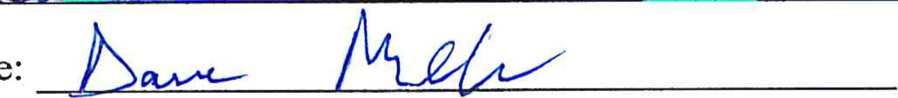 Date: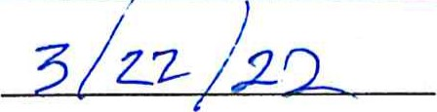

28